**SOLVING OPTIMIZATION PROBLEMS**

**DIFFERENTIATION**

**MAXIMA AND MINIMA**

**VECTOR CALCULUS GRAD**

**GRADIENT DESCENT: GEOMETRIC INTUITION**

**LEARNING RATE**

**GRADIENT DESCENT FOR LINEAR REGRESSION**

**STOCHASTIC GRADIENT DESCENT (SGD)**

**CONSTRAINTS AND PCA**

**WHY L1-REGULARIZATION CREATES SPARSITY?**

# **DIFFERENTIATION**

The idea of Differentiation and Maxima,Minima is used in 99% of Machine Learning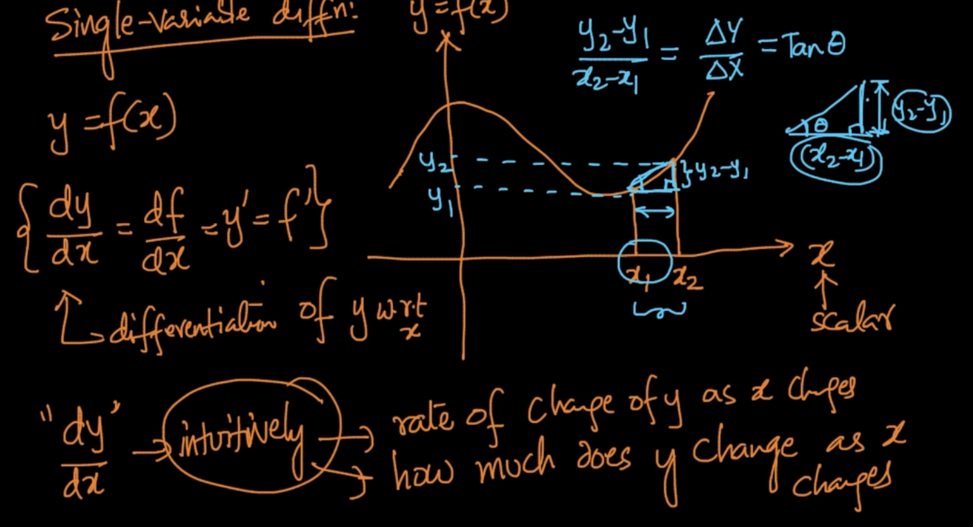

dy/dx - Rate of change of y as x changes. dy/dx = $\frac{y_{2}-y_{1}}{x_{2}-x_{1}}$ = $\frac{Δy}{Δx}$ = $Tanθ$

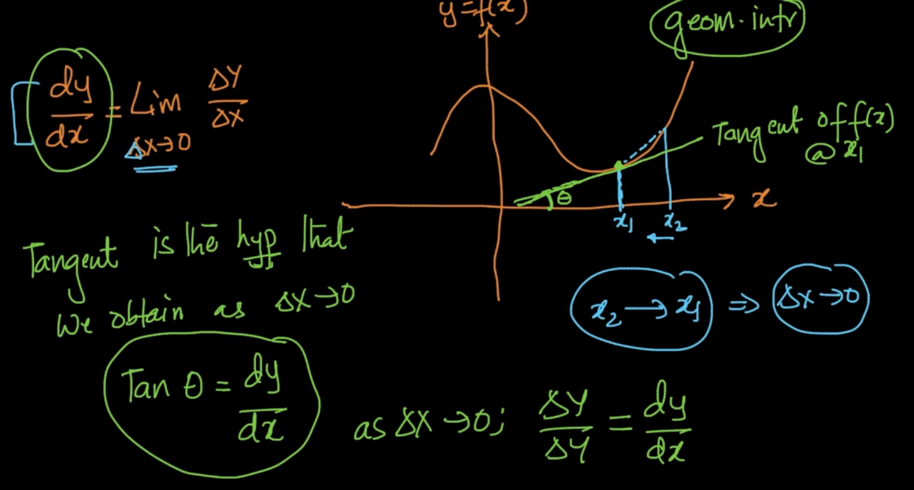

dy/dx = $\lim_{Δx→0}\frac{Δy}{Δx}$.Let’s break down it. The derivative of y w.r.t x (dy/dx) is equal to rate of change of y w.r.t rate of change of x i.e ($\frac{Δy}{Δx}$) and $Δx$ i.e $x_{2}$- $x_{1}$ is close to 0.

If $Δ x$ is 0 then the tangent of f(x) at that point x is our (dy/dx) and it’s $θ$ is angle between slope and x-axis

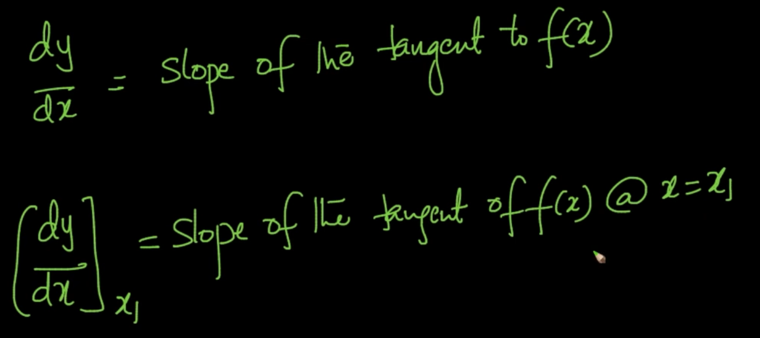

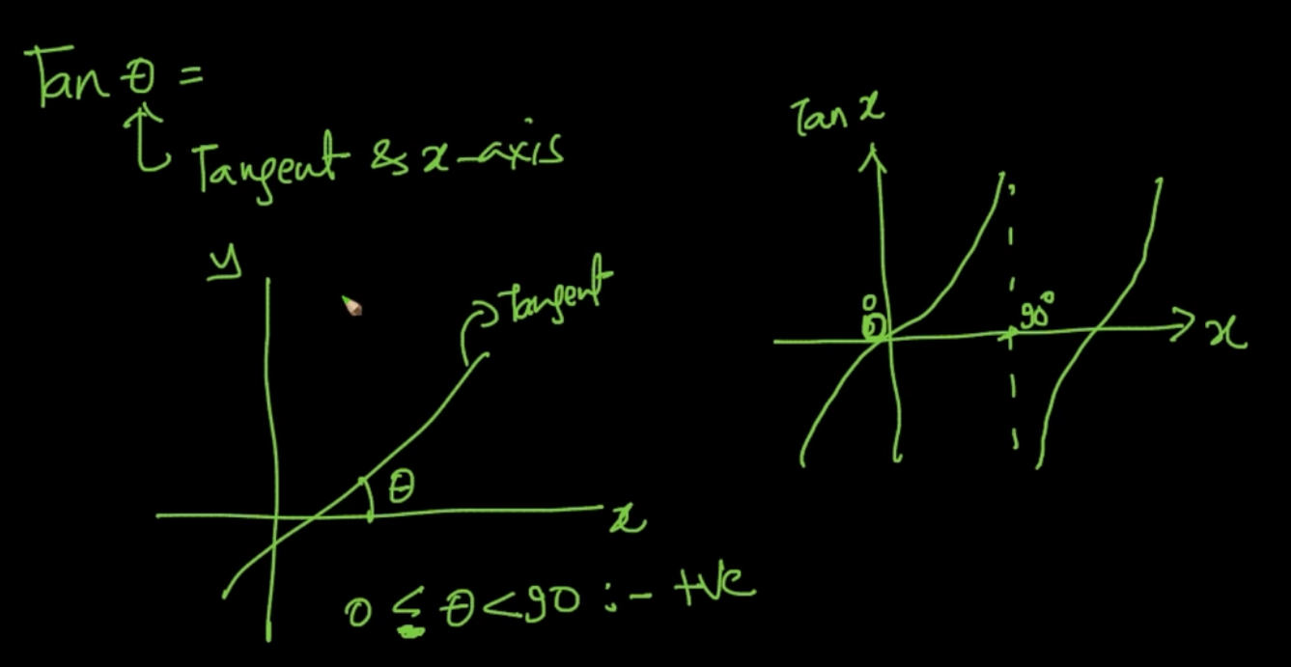

Tangent when 0 < $θ$ < 90 is positive

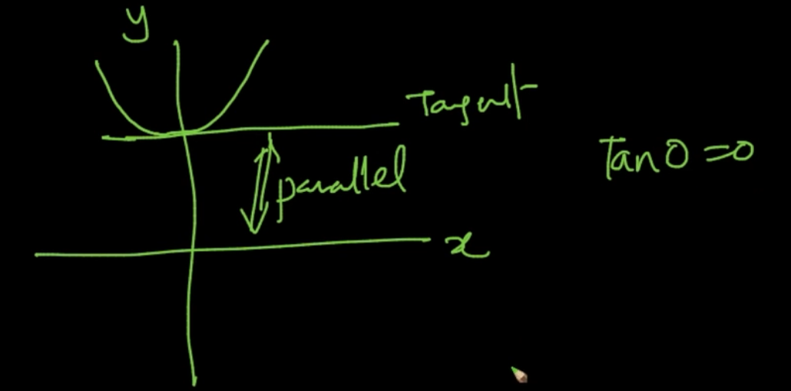

When $θ$ = 0 tangent is parallel to x-axis

Tan 90 is undefined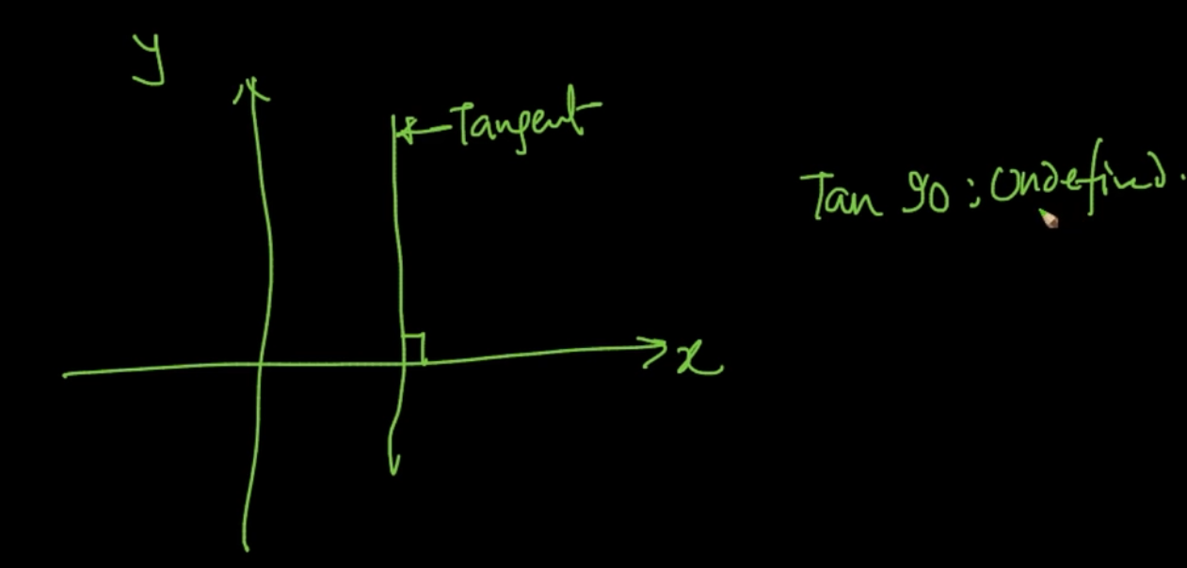

Tan $θ$ is negative when 90 < $θ$ < 180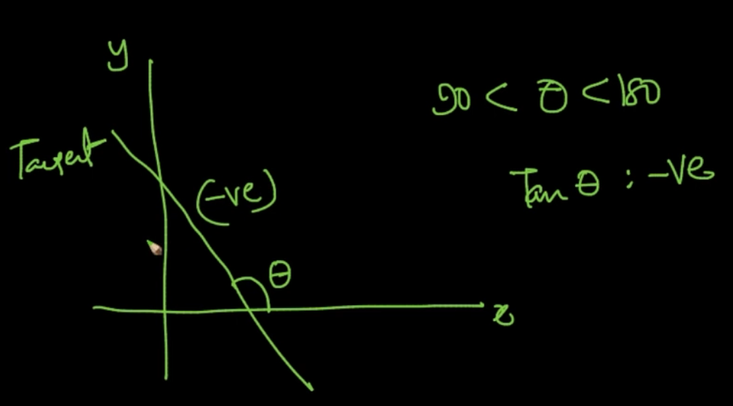

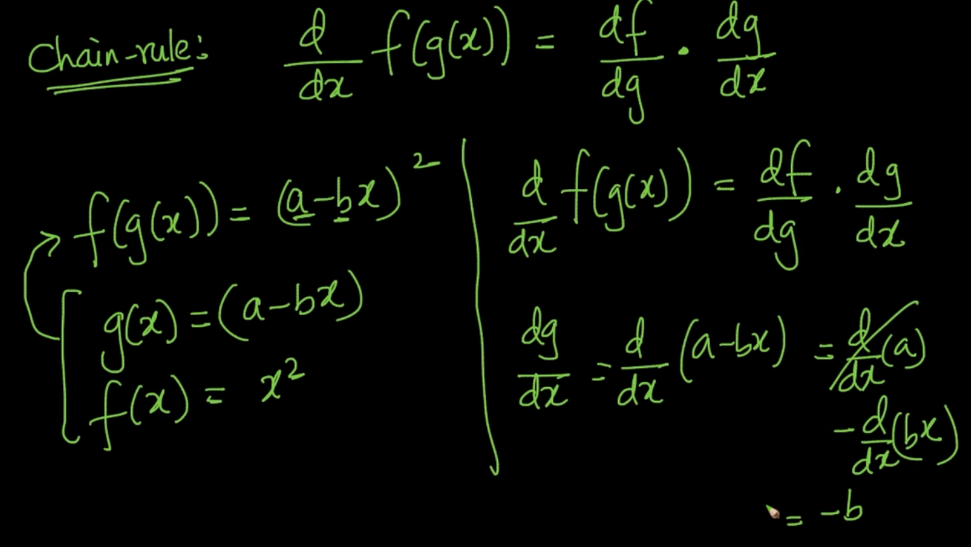

It’s the most important concept of Calculus in Deep Learning and Machine Learning.

$\frac{d}{dx}$ (f(g(x)) = $\frac{df}{dg}$. $\frac{dg}{dx}$. First, we’ll calculate $\frac{dg}{dx}$.Now, calculate df/dg.

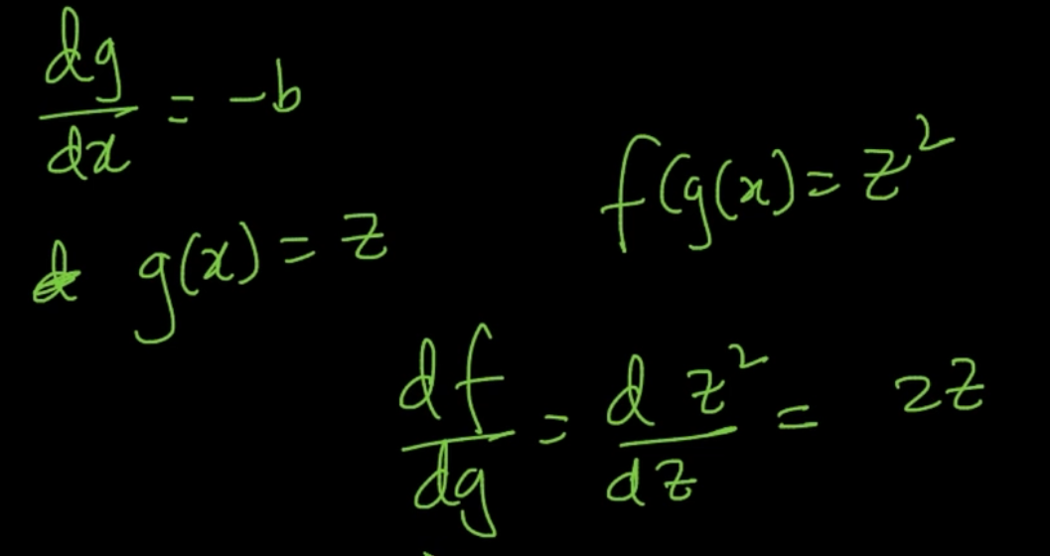

If we take g(x) = z then f(g(x)) = $z^{2}$ for the above f(g(x)) so df/dg = 2z

So $\frac{df}{dg}$. $\frac{dg}{dx}$ = 2.(a-bx). -b for the above problem

# **MAXIMA AND MINIMA**

At minima and maxima the slope is = 0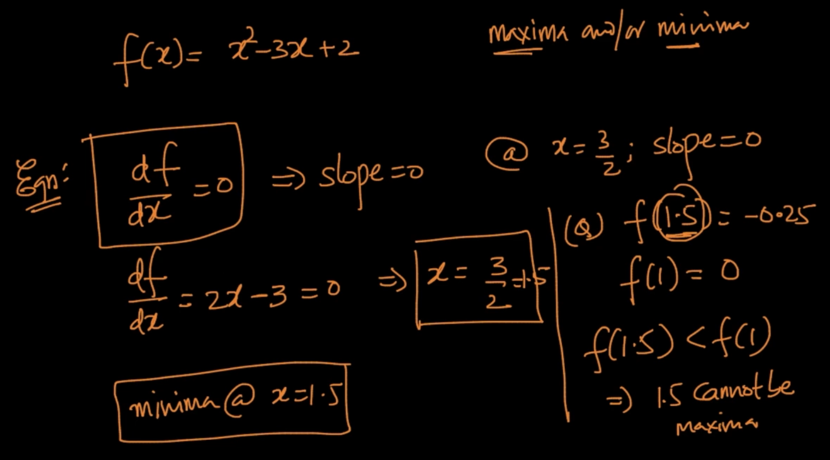

We know that df/dx is our slope so if we make it = 0 then we can get the value of maxima/minima. We are calculating df/dx = 0 and getting the value of x. So, f(x) would tell us the minima/maxima but we don’t know whether it’s telling maxima or minima .For this we calculate f(x) for a near value towards it. Here, df/dx = 0 at x = 1.5 and f(1.5) = -0.25

We take f(1) which is 0 , Since f(1.5) < f(1) it cannot be maxima so it’ll be minima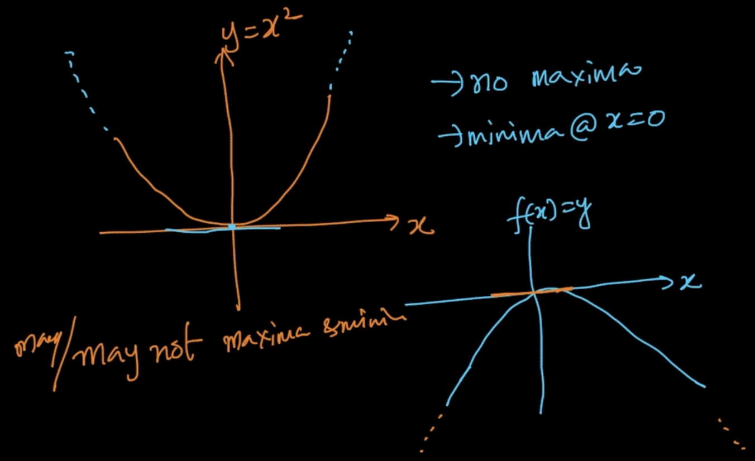

There can be some functions which might not have maxima/minima . Ex: In the above orange figure there’s only minima not maxima and vice-versa for the blue figure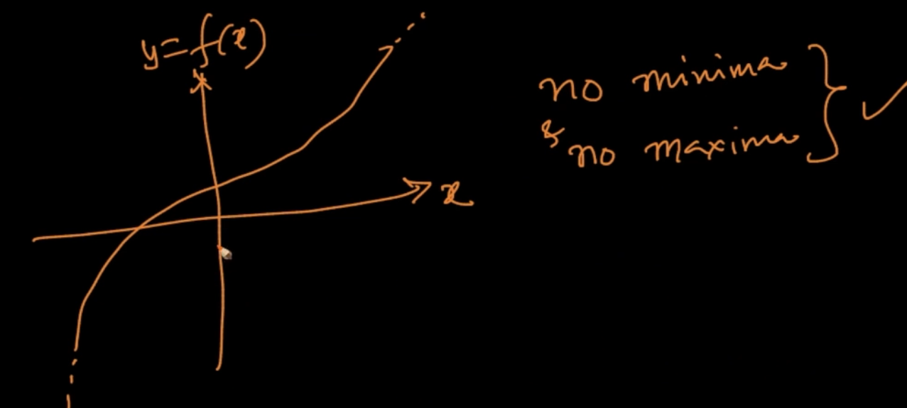

There can be some functions which might not have maxima/ minima

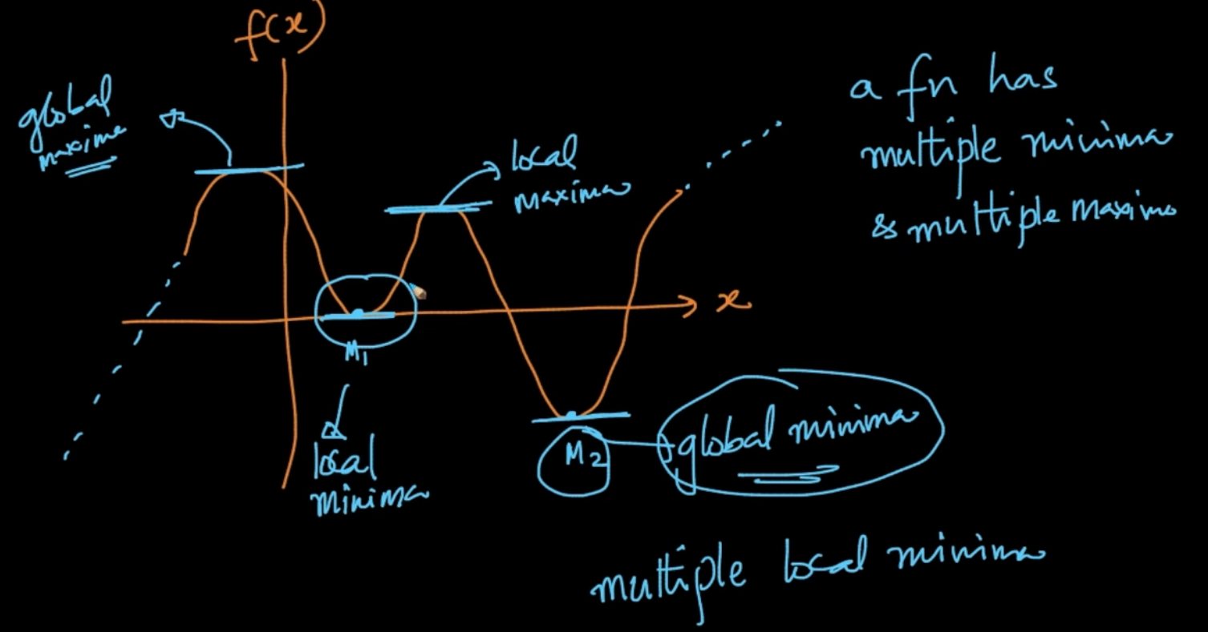

A function can have multiple maxima and minima as seen above.

**Local Minima/ Maxima** - It’s the Minimum /Maximum in the neighborhood as seen above

**Global Maxima/Minima** - It’s the Minimum/ Maximum among all the Minimums/ Maximums

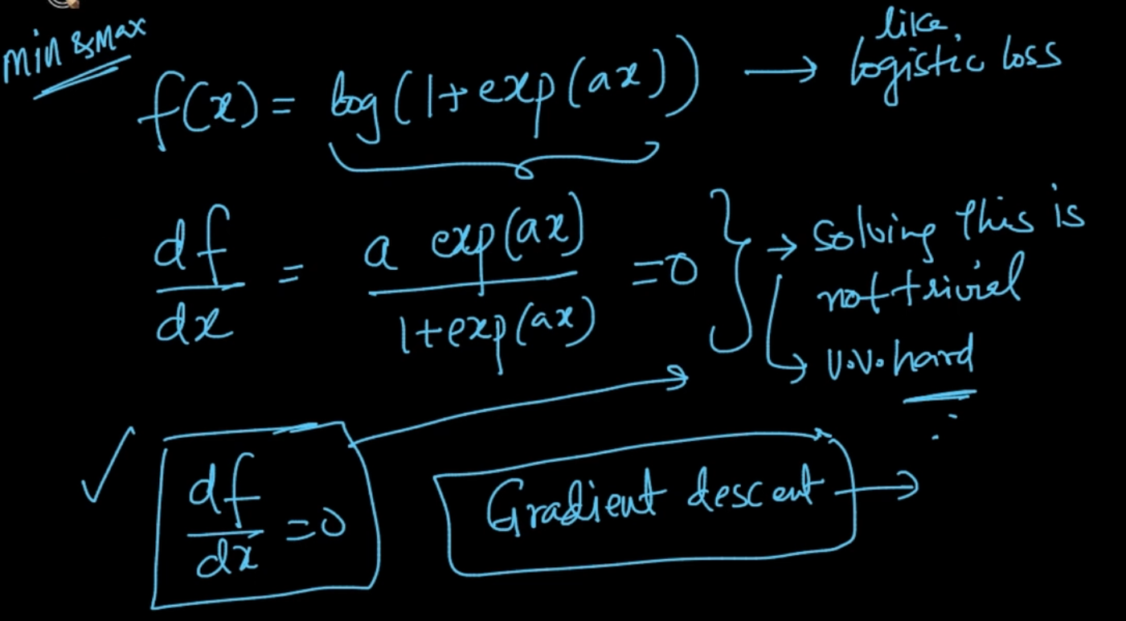

Some functions cannot be solved by simple df/dx = 0. So, we’ll use Gradient Descent for that

# **VECTOR CALCULUS GRAD**

We’ve dealt with scalars in Differentiation but in ML things are in vector. So we’ll deal with vector calculus. Our , y = f(x) = $a^{T}x$ where x is vector and a is a vector of constants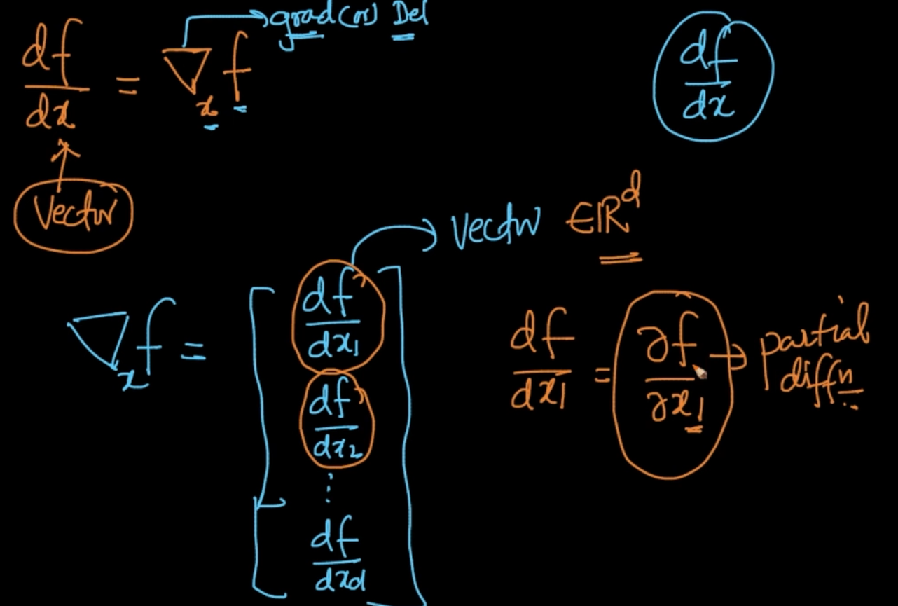

df/dx = $▽_{x}f$ which is Del ($▽$) of f w.r.t x as seen. This is differentiation of vector

As seen above it’s $▽_{x}f$ = [df/dx1, df/dx2…..df/dxd] but df/dx1 is partial derivation and we write it as $δf/ δx1$. It means that x has <x1,x2,x3…...xd> but we are derivating the function with only one component x1 at a time not the whole x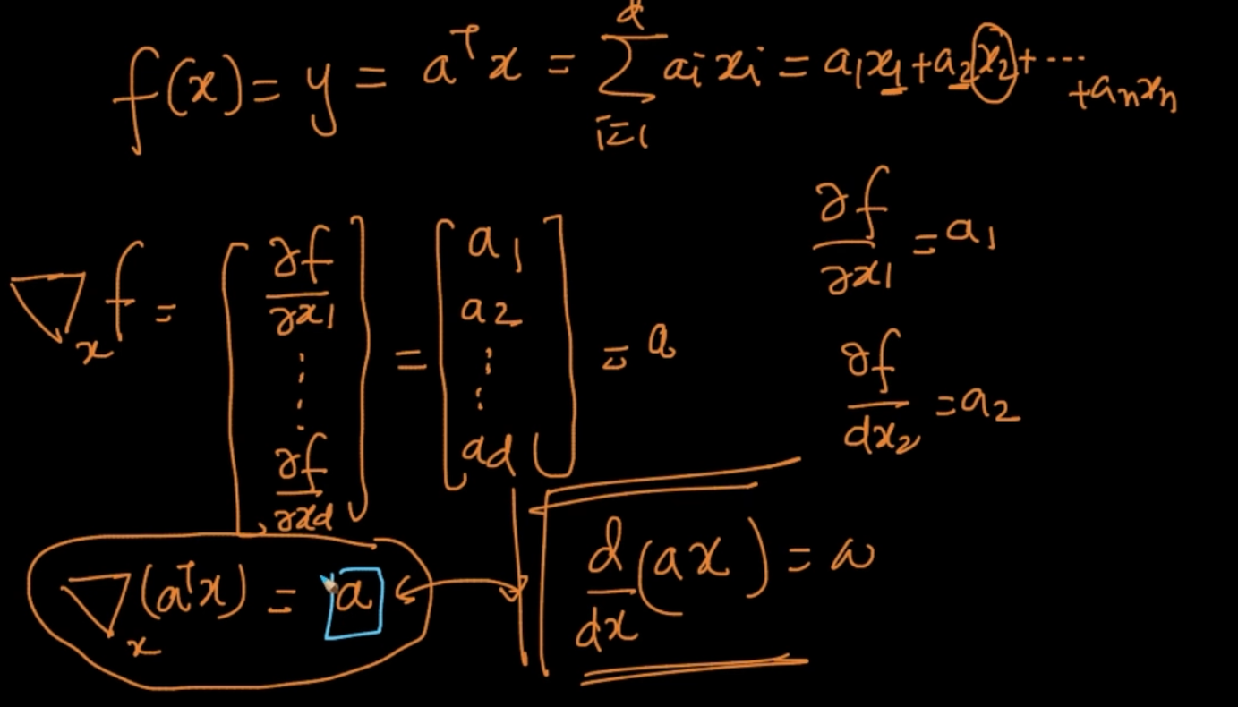

y = $a^{T}x$ = $a_{1}x_{1}+a_{2}x_{2}$ +...... $a_{n}x_{n}$. So when we do the derivation of above . We’ll get ‘a’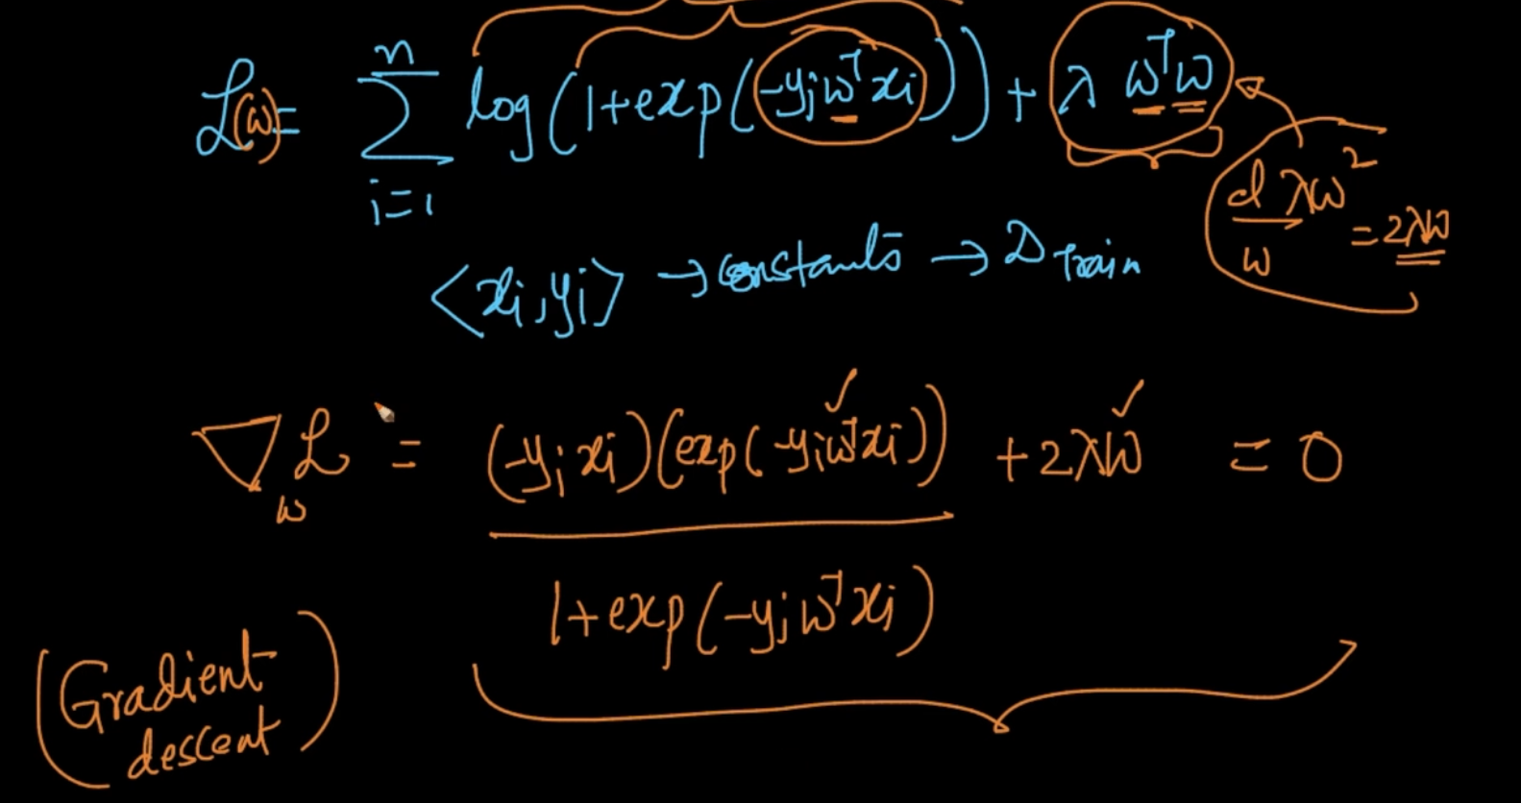

Finding minima.maxima with $⛛_{x}L$ is very hard because the equation is complex af.

So, we’ll apply computational techniques like Gradient Descent to solve it

# **GRADIENT DESCENT: GEOMETRIC INTUITION**

Gradient descent is an iterative algorithm. In an Iterative algorithm first we’ll guess the value

of $x^{*}$ (Point where we want to reach)which is $x_{0}$. Now by applying our iterative algorithm Gradient Descent we’ll get $x_{1}$ which is closer to our targeted $x^{*}$ than $x_{o}$

We want to find $x^{*}=$ argmin f(x) where we want to minimize f(x). min f(x) = max(-f(x)) and vice versa. One important observation here is that the slope change it’s sign from +ve to -ve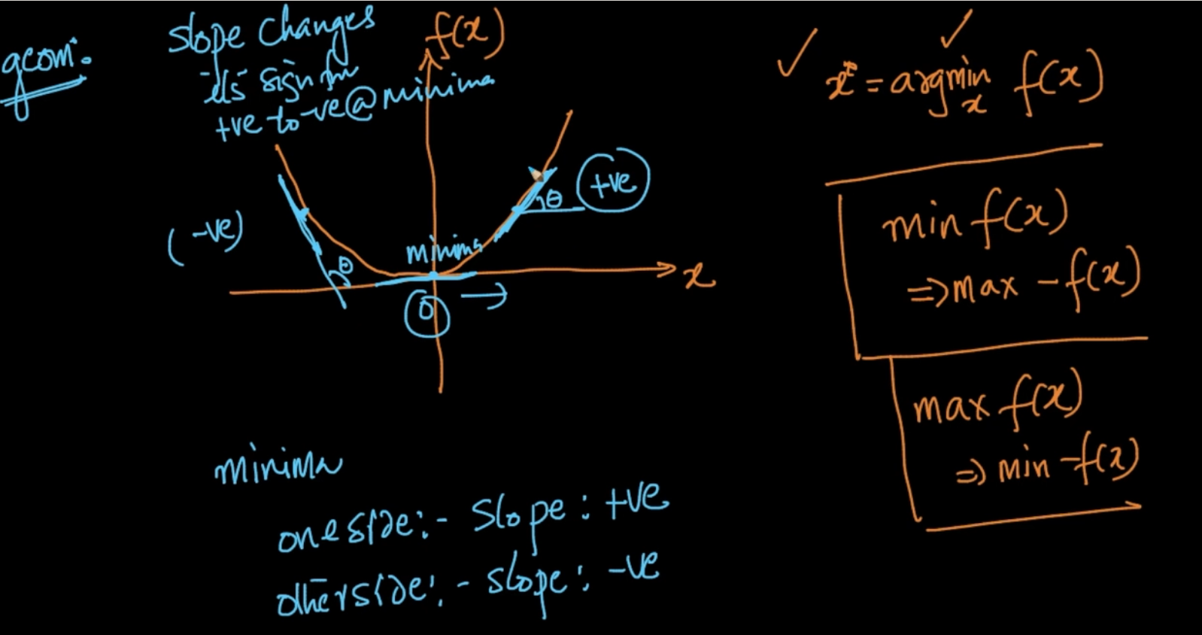

After reaching minima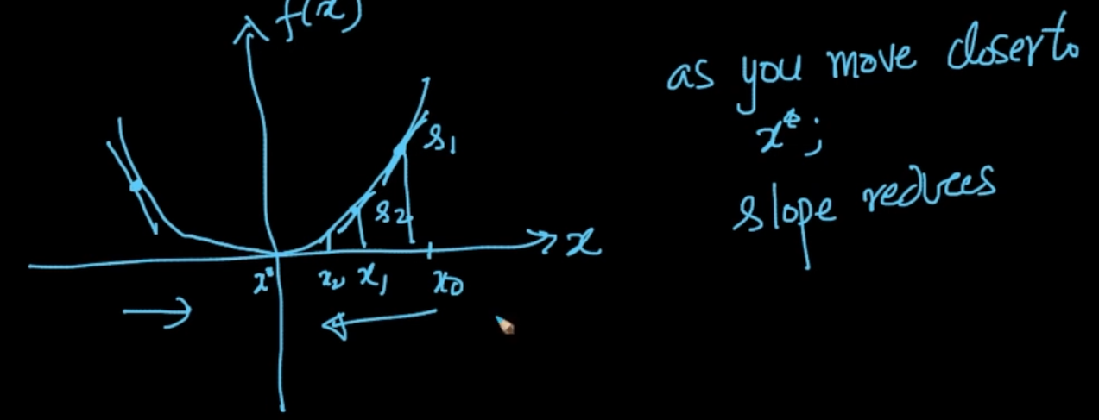

Another observation is as we move closer to $x^{*}$ from the right side the slope reduces

And it increases if we move from left to right. So , let’s see how Gradient Descent works

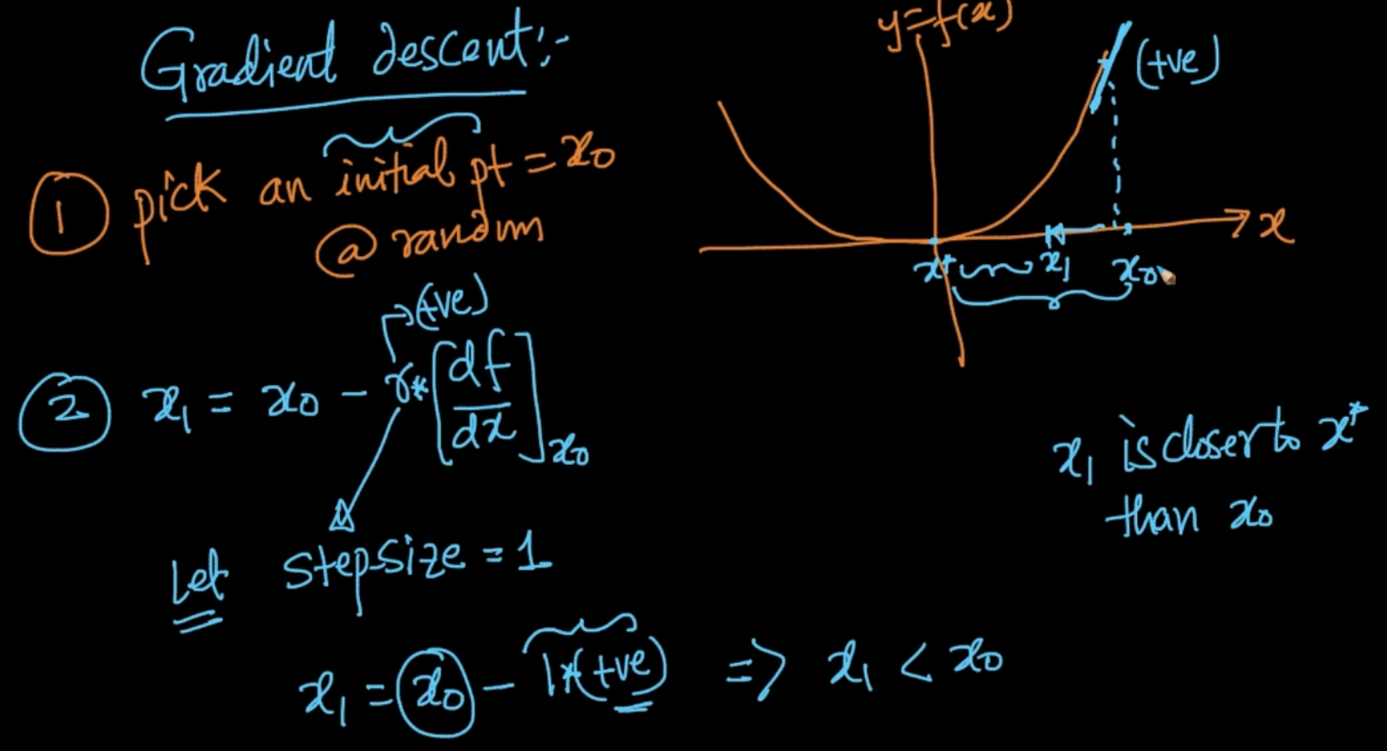

1) We’ll pick a random initial point =

2) = - where ‘r’ is step-size and $\frac{df}{dx}$ is the slope . Also, $x_{1}< x_{0}$ 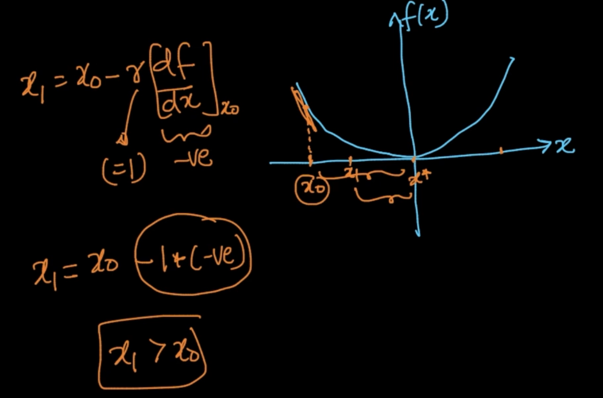

Case 2: When $x_{0}$ is at the other side

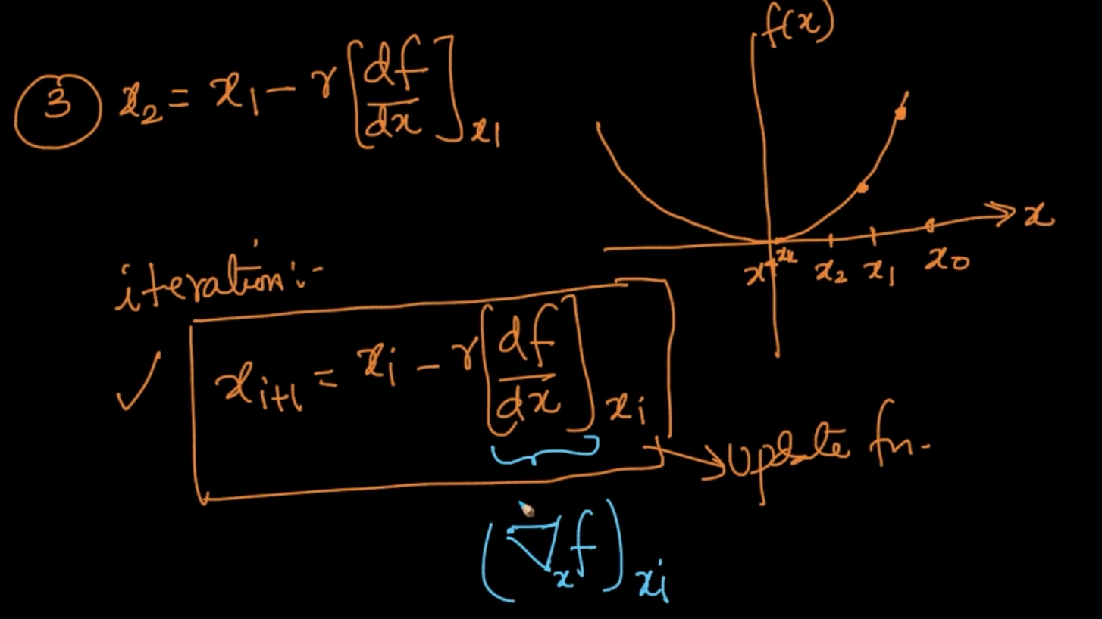

We’ll calculate $x_{2}$ from $x_{1}$. Our algorithm will do iteration. When will it stop but?

We’ll terminate the loop once the difference between two iterations are very small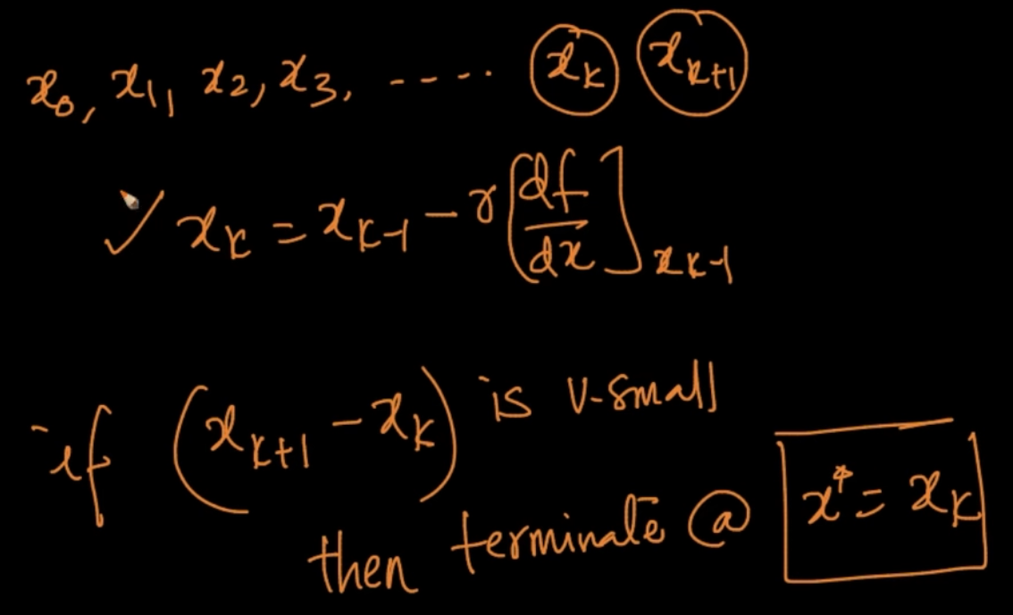

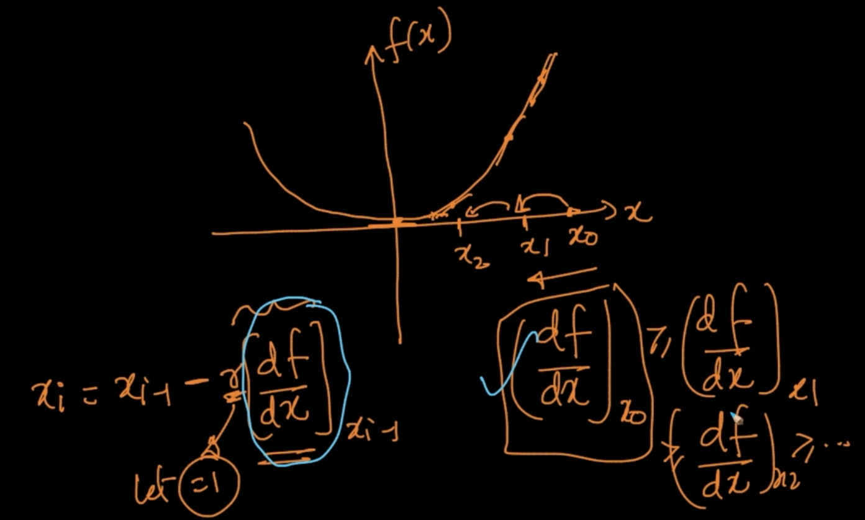

${ [\frac{df}{dx}]}_{x0}>$ ${ [\frac{df}{dx}]}_{x1}$ > ${ [\frac{df}{dx}]}_{x2}$…. As we can see since the derivatives are getting smaller and smaller by each iteration. We are taking a huge step and as we are moving to the convergence our step -sizes are getting smaller and smaller . This is what happens in Gradient Descent

# **LEARNING RATE**

‘r’ is basically learning rate or step-size

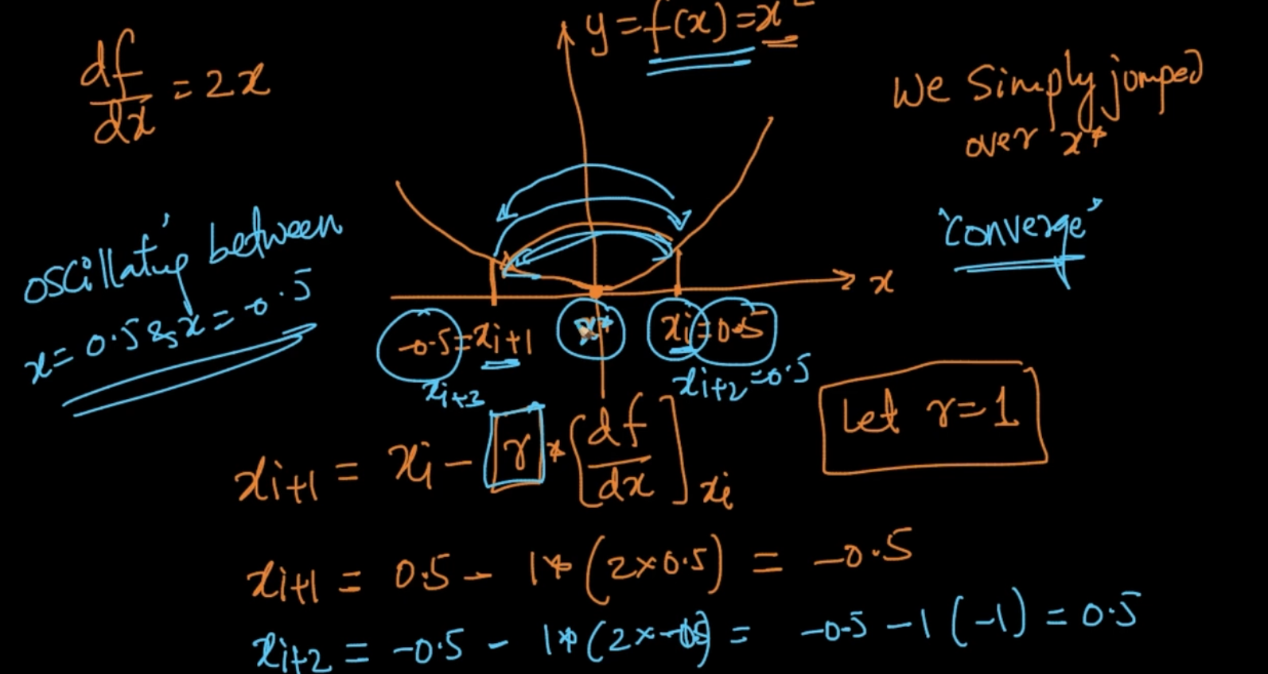

As we can see at $x_{i+1}$ = -0.5 so we are jumping over $x^{*}$ and at $x_{i+2}$ = 0.5 so we are oscillating between -0.5 and +0.5 but never converging towards $x^{*}$ as our r = 1

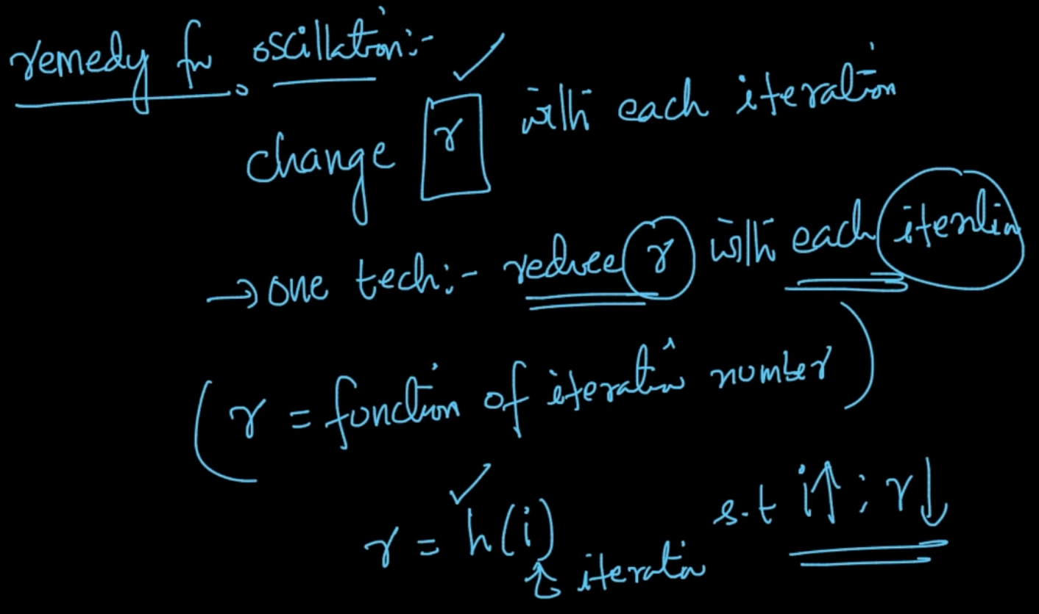

One method is to reduce r with each iteration. So we want to make r = h(i) where h is a function such that as i increases r should be decreased

# 

# **GRADIENT DESCENT FOR LINEAR REGRESSION**

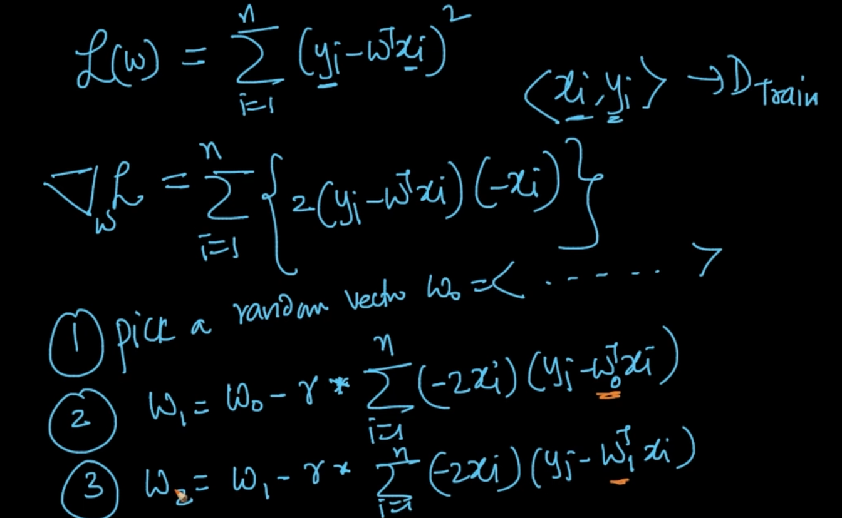

L(w) is a function for ‘w’ and we want to find the best w not x as x,y are constants as given in our dataset. So we need $⛛_{w}L$. We pick a random vector $w_{o}$ and apply it to get the next

$w_{1}$. $w_{1}$ will be used to get $w_{2}$ and this step will be repeated till difference between $w_{k}$ and $w_{k+1}$ is very small . If that’s the case then $w^{*}$ = $w_{k}$ 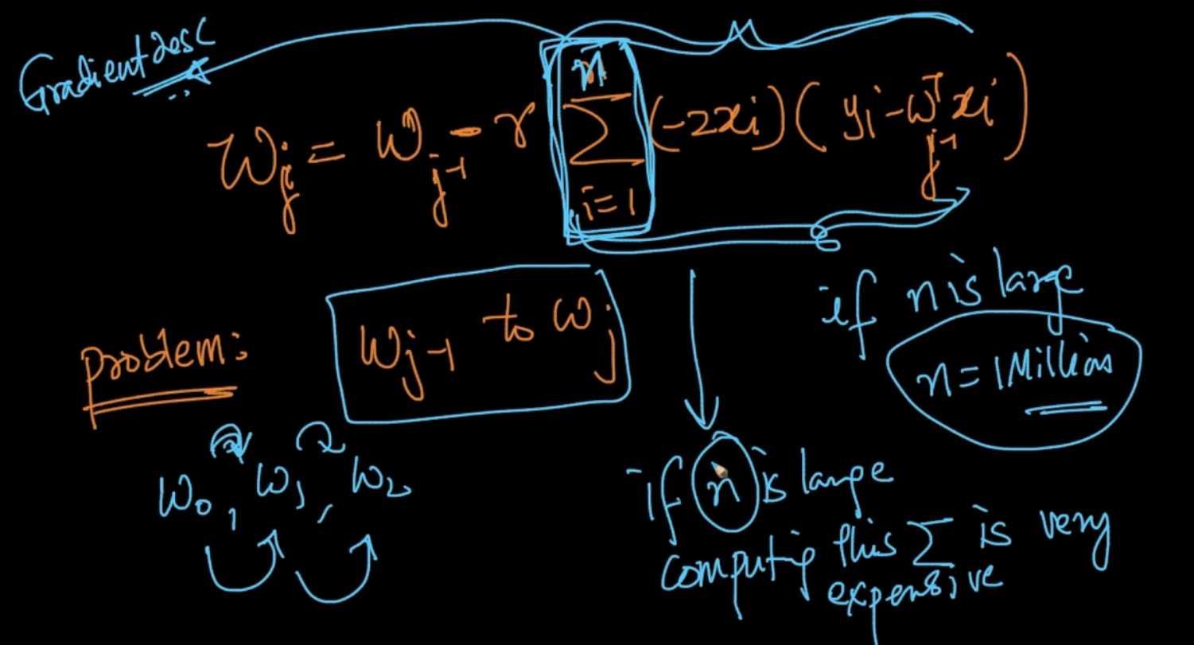

There’s one problem here i.e for every iteration in w i.e w0,w1.. we need to calculate

The summation thing and if ‘n’ is very large then we need to do it n times for every iteration

# **STOCHASTIC GRADIENT DESCENT (SGD)**

Stochastic Gradient Descent is the most important optimization algorithm in ML

In Gradient Descent , we’d the problem for w as for every iteration we’d to go through the whole dataset and if n-No. Of inputs is large we are fucked.

We can use SGD (Stochastic Gradient Descent) in which we do the same operation but instead of ‘n’ we use ‘k’ where k << n and it is random set of points from the dataset

We can infer that ${w_{GD}^{*}}^{}= w_{SGD}^{*}$.

NOTE - With every iteration of w i.e $w_{j+1}$ => $w_{j+2}$ we are changing the value of k

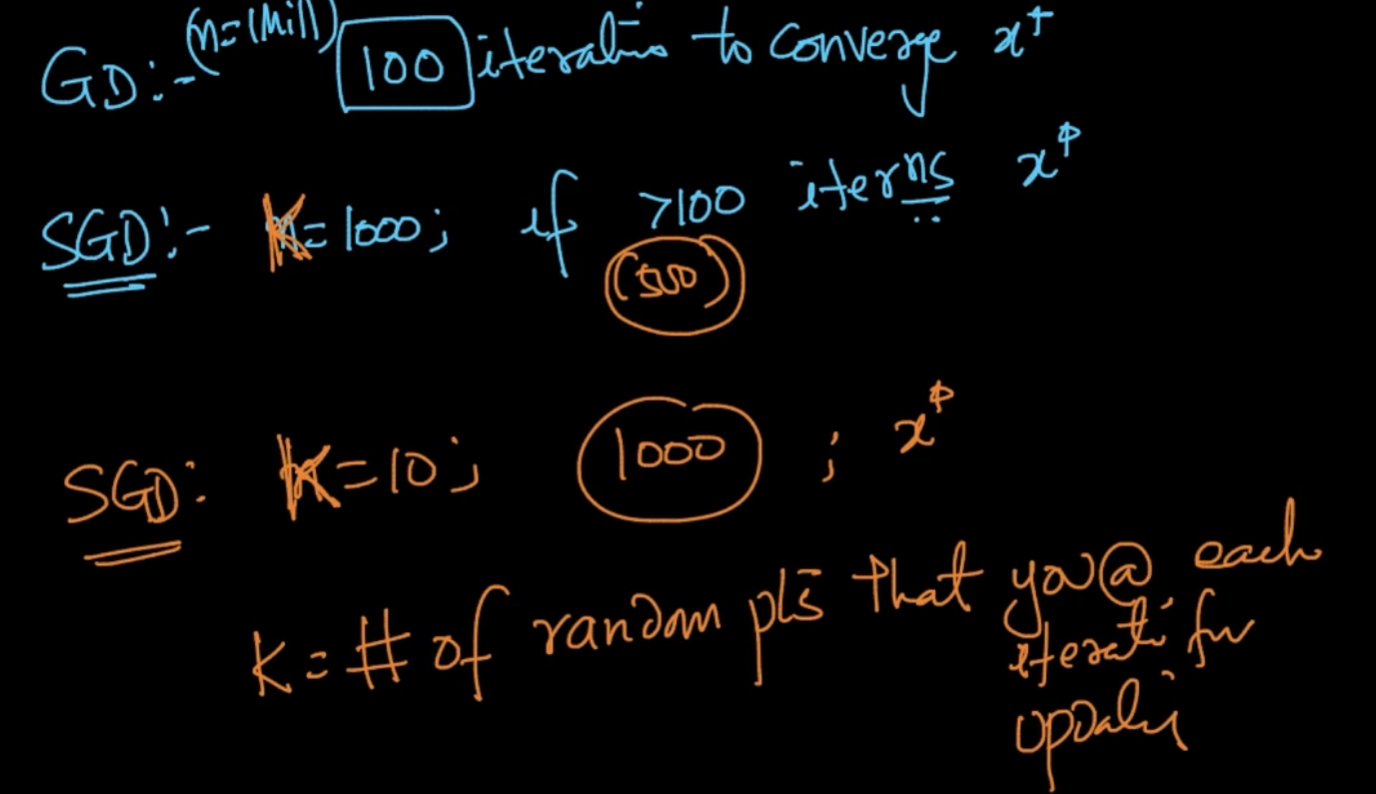

If Gradient Descent, n = 1 Million points and it takes 100 iterations to converge $x^{*}$ but in

SGD, if k = 1000, then it’ll take >100 iterations to converge. Let’s say 500.Same for k = 10

K: is also called batch size as we are using batch of random points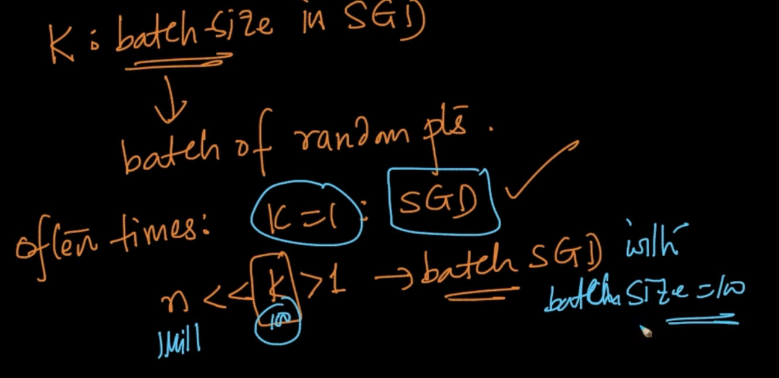

# **CONSTRAINTS AND PCA**

We want to maximize a function f(x) with a constraint i.e g(x) = c. How will we tackle problems when dealing with situations like this

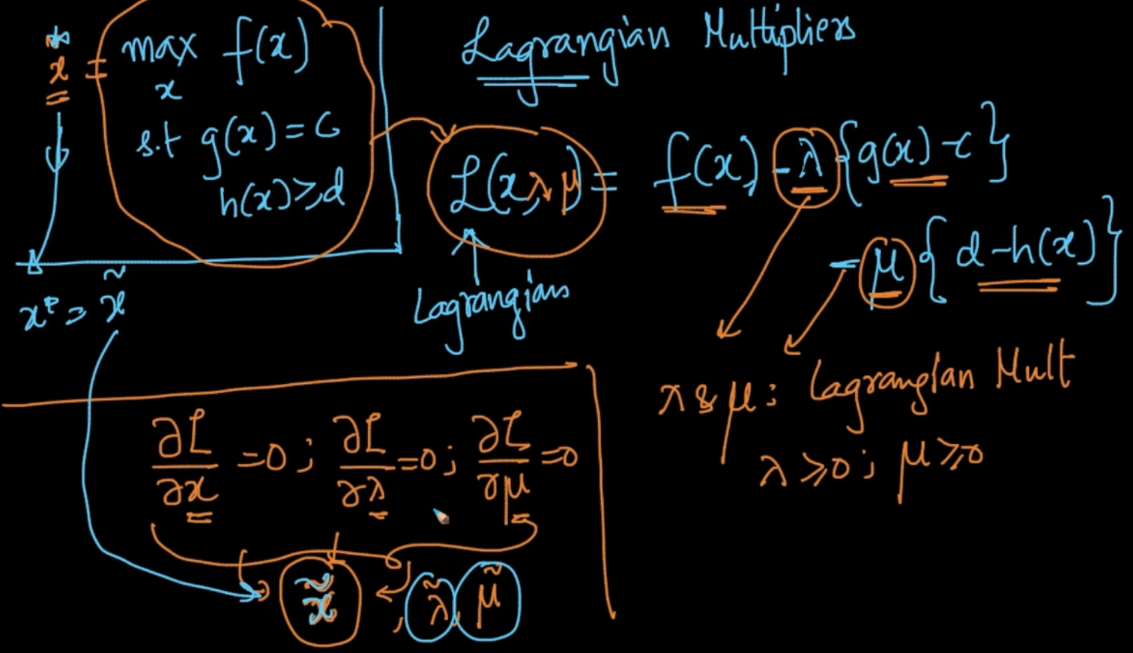

When we need to find a max of function with constraints we add Lagrangian Multipliers

$λ, μ$ as seen above. Now take the derivatives w.r.t x, $λ, μ$ as seen above. We’ll get $x\sim$, which will be equal to x* that we wanted

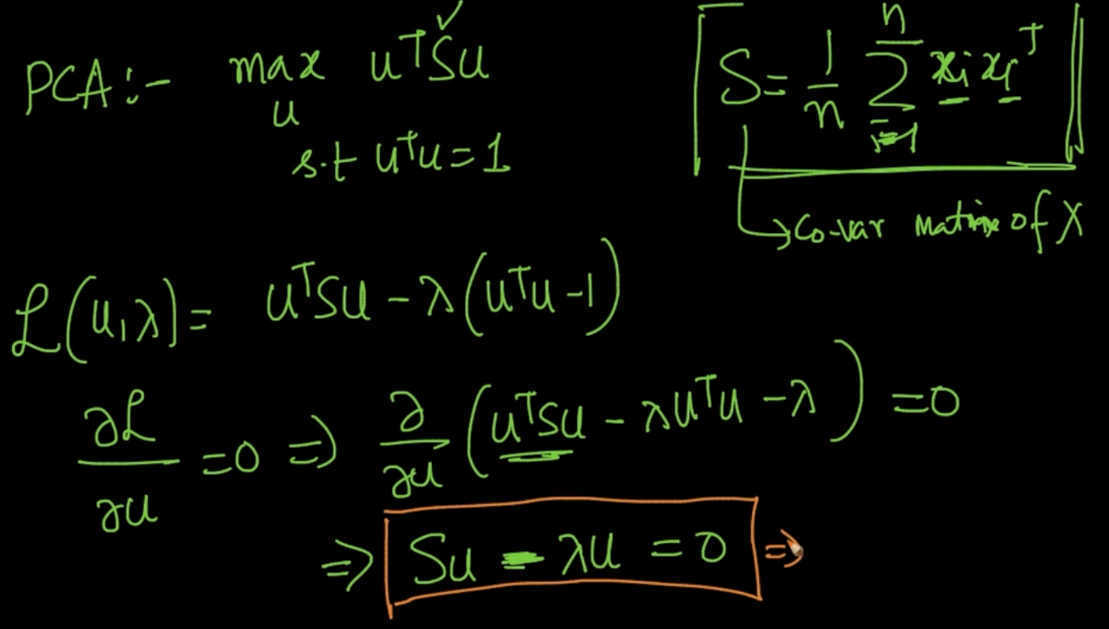

In PCA, we want the max of $u^{T}Su$ such that $u^{T}u = 1$ where S is covariance matrix

We take the derivative of L w.r.t u = 0 and we get Su - $λ$ u = 0

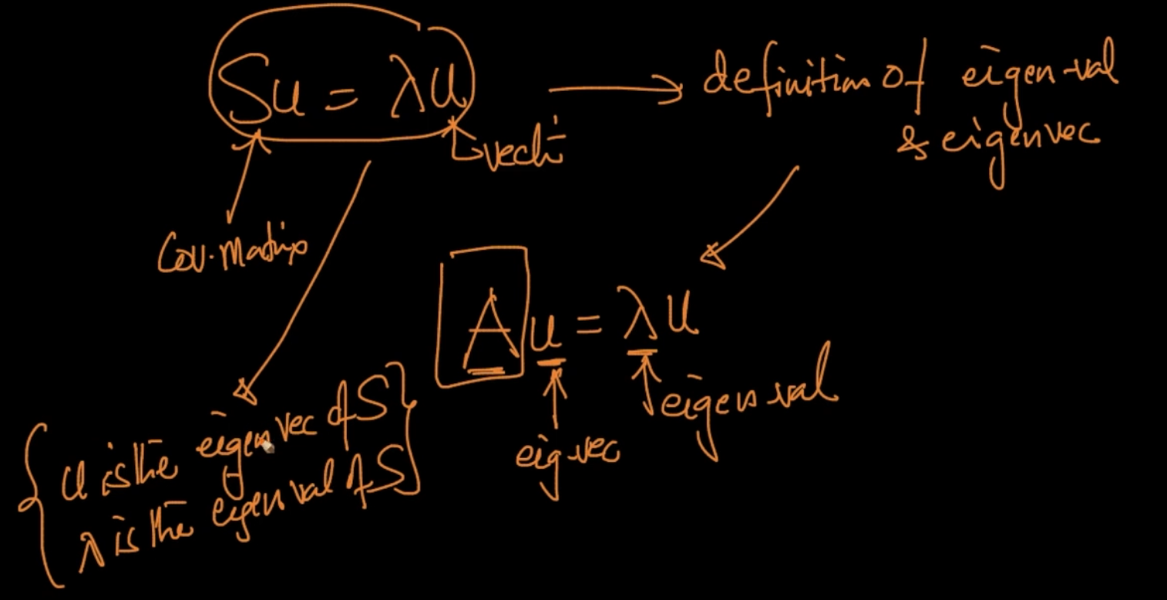

u is the eigen-vector of S and $λ$ is the eigen-value of S as it’s the same we’d seen in PCA

**LOGISTIC REGRESSION REVISITED**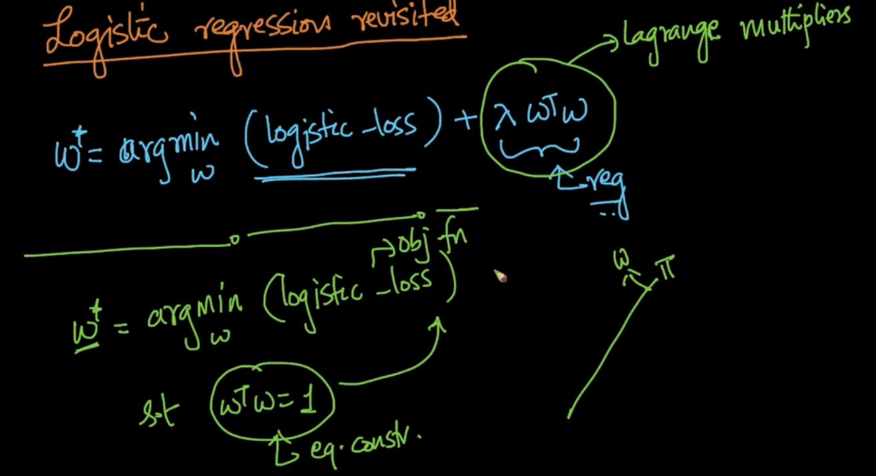

We want to find w* such that $w^{T}w$ = 1

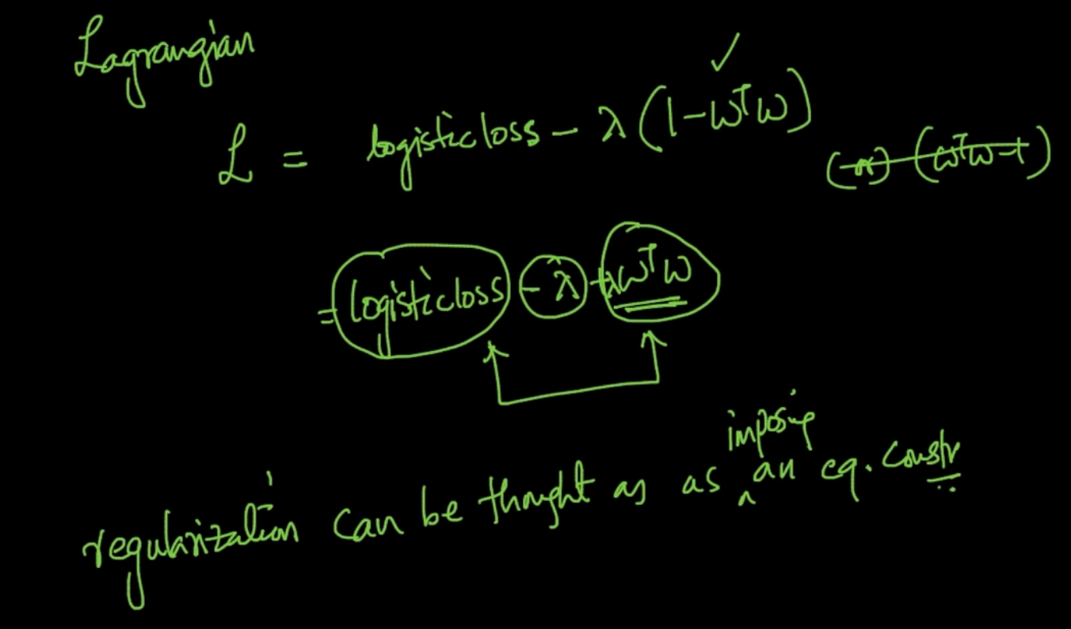

When applying Lagrangian we get the value same as w* in which regularization was also there. So regularization can also be thought as imposing an equality constraint

# **WHY L1-REGULARIZATION CREATES SPARSITY?**

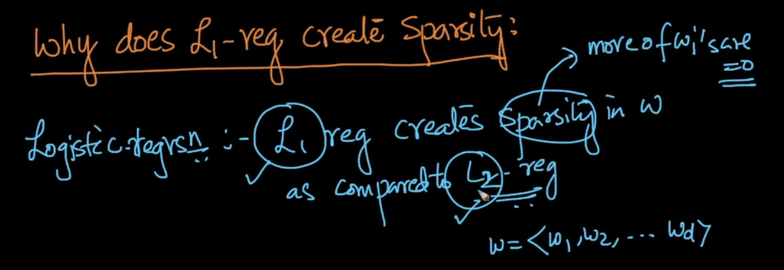

$L_{1}$ regularization creates sparsity in ‘w’ as compared to $L_{2}$ regularization. Let’s see why it happens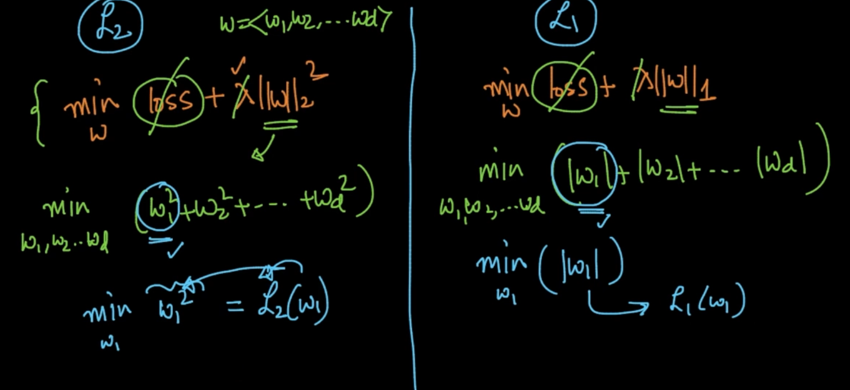

In both the Regularizations, we are ignoring the Loss and $λ$. So, our goal is just to minimize ‘w’. In $L_{2}$, we want to minimize ($w_{1}^{2}+ w_{2}^{2}$ + $w_{3}^{2}$ + …. + $w_{d}^{2}$) and in $L_{1}$ we want to minimize

(|| + ||+ …… ||). Let’s se contribution of just $w_{1}$ to our regularization in L i.e (L($w_{1}$))

For $L_{2}$, min of $w_{1}^{2}$ is the contribution of $w_{1}$ to $L_{2}$ regularization

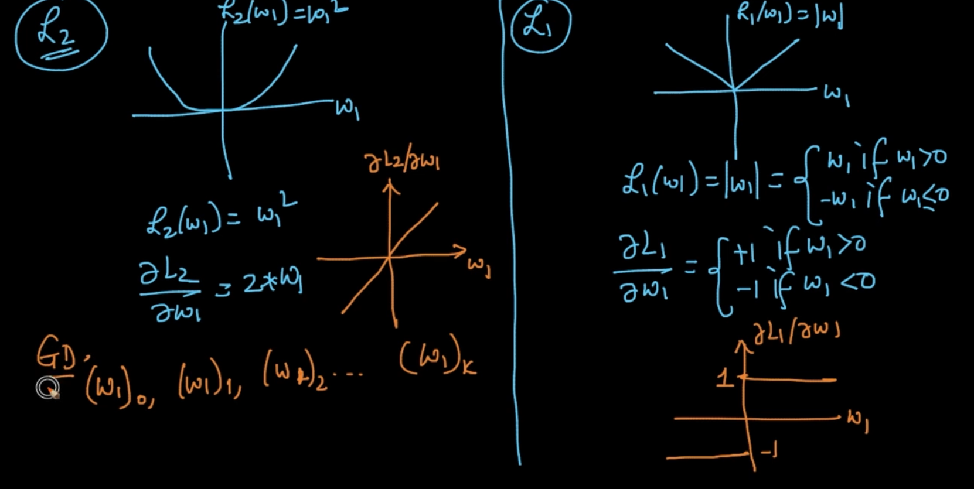

We are plotting the graphs of $w_{1}v.s L_{2}(w_{1}),$ $w_{1}v.s L_{1}(w_{1})$ and its derivative graph.

Our gradient Descent calculates it for each iteration of $w_{1}$ till it converges

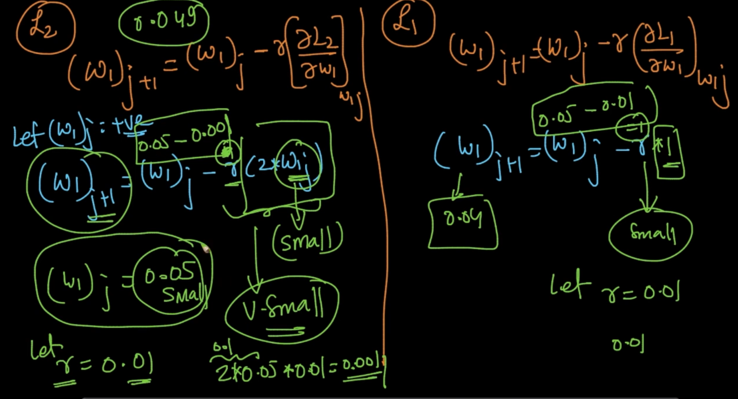

So, our $w_{1}$ at j’th iteration = 0.05 and r = 0.05. In $L_{2}$, ${(w_{1})}_{j+1}$ = 0.05 - 0.001 = 0.049 and in

$L_{1}$, ${(w_{1})}_{j+1}$ = 0.05 - 0.01= 0.04 so our $L_{1}$ is already close to 0 as compared to $L_{2}$

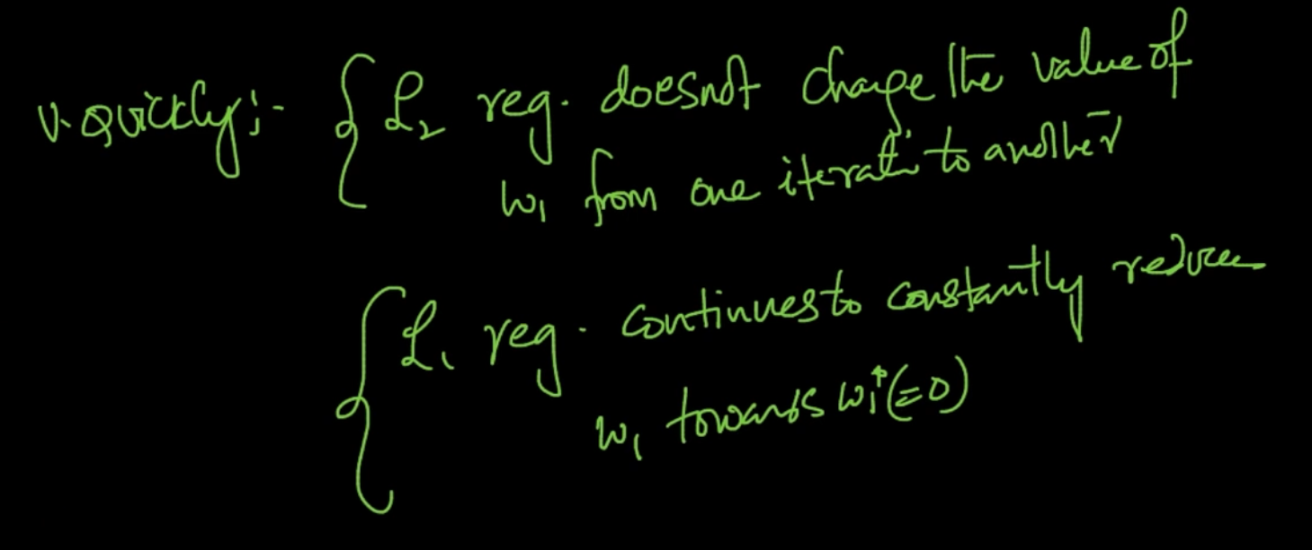

It can be seen that $L_{2}$ regularization is slow at converging with each iteration whereas

$L_{1}$ constantly changes as it has a constant slope/gradient so it converges faster towards

${w_{1}^{*}}_{}$

# 